Raster Scan Display:
A Raster Scan Display is based on intensity control of pixels in the form of a rectangular box called Raster on the screen. Information of on and off pixels is stored in refresh buffer or Frame buffer. Televisions in our house are based on Raster Scan Method. The raster scan system can store information of each pixel position, so it is suitable for realistic display of objects. Raster Scan provides a refresh rate of 60 to 80 frames per second.
Frame Buffer is also known as Raster or bit map. In Frame Buffer the positions are called picture elements or pixels. Beam refreshing is of two types. First is horizontal retracing and second is vertical retracing. When the beam starts from the top left corner and reaches the bottom right scale, it will again return to the top left side called at vertical retrace. Then it will again more horizontally from top to bottom call as horizontal retracing shown in fig:
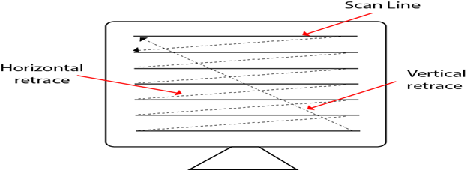
Types of Scanning or travelling of beam in Raster Scan
- Interlaced Scanning
- Non-Interlaced Scanning
In Interlaced scanning, each horizontal line of the screen is traced from top to bottom. Due to which fading of display of object may occur. This problem can be solved by Non-Interlaced scanning. In this first of all odd numbered lines are traced or visited by an electron beam, then in the next circle, even number of lines are located.
For non-interlaced display refresh rate of 30 frames per second used. But it gives flickers. For interlaced display refresh rate of 60 frames per second is used.

Advantages:
- Realistic image
- Million Different colors to be generated
- Shadow Scenes are possible.

Disadvantages:
- Low Resolution
- Expensive

